**Exercise 2 – Git Ignore**

* Creating a log file inside a log folder.



* Creating a git ignore file in the root directory



The above lines mean that the “logs” folder and anything that has a “.log” extension will be ignored when git tries to push to its remote.

**Checking the status now.**

Let’s check the directory contents before.

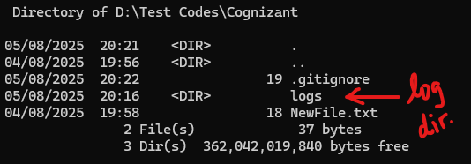

Let’s stage / add all the files in the current directory using `git add .` command and check the status of the repository using `git status`.

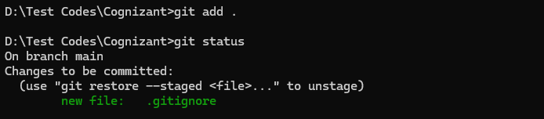

As you can see, only the **.gitignore** file was added. The logs folder and the log file wasn’t included.